Kangen Water has been the leading brand of ionizers since 2003. But in recent years there's been a mass of ionizer companies that claim to produce the same technology for a fraction of the cost confusing uneducated shoppers.
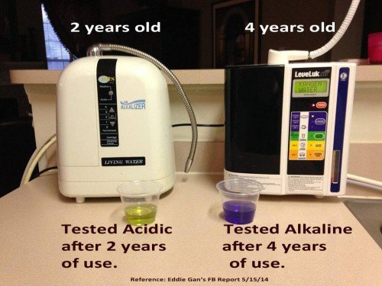
New York, USA / ACCESSWIRE / October 25th, 2014 / Since Enagic’s inception into the United States from Japan in 2003, Kangen Water(™) machines has been the leading provider in ionizer technology with sales by far surpassing that of their competitor counterparts. Many have to wonder why most people choose to pay the extra expense when there is a plethora of companies on the internet claiming to produce the same technology at a fraction of the cost.
For a short time, online ionizer manufacturers have made progress deterring Kangen Water(™) shoppers into buying cheaper machines through aggressive online campaigns. Recent available education on ionizer technology has caused a rift with Kangen Water(™) shoppers who previously had limited information to make an informed decision of which ionizer to buy. This has prompted awareness campaigns both of ionizer construction and of ionizer construction cost. Websites likewww.TryKangenNow.net aims to teach consumers about how to compare an ionizers engine’s size and what warning signs to look out for when choosing an ionizer system.
Because the engines of all ionizers are made up of platinum and titanium, two very expensive metals, a great majority of the cost coincides with the overall surface area and size of the ionizer’s engine. Cheap ionizer companies sell their systems at a reduced cost because of the reduction of quality of these precious metals and also the reduced quantity of these precious metals. The reduced quality and quantity ultimately results in the reduced quality of water. An online search of numerous ionizer manufacturers found that only one company stated the actual size of each electrode plate on their website; www.BuyKangenWaterDistributor.com, which is an independent Kangen Water distributor website.
Alkaline water enthusiast, Phil Montierde of Queens, New York said, “When you buy a cheap ionizer that’s exactly what you get. It doesn’t taste the same and the benefits are not the same while drinking Kangen Water(™). No wonder every single company tries to compare themselves to Kangen Water(™) machines.”
Disgruntled ionizer customer Ericka Valle of Staten Island, New York said, “How is the general public supposed to know about ionizer engine size? When researching which system to buy companies just said it does the same thing Kangen Water(™) machines does. Not stating the actual engine size on the website is misleading.”
Kangen Water(™) shoppers today aren’t so easily fooled. With big time mentions in publications like New You Magazine, GQ Magazine and Harper’s Bazaar Magazine, as well as endorsements from the elite in Hollywood, numerous doctors and fitness experts like Jillian Michaels and Quincy Dolvet, there is enough evidence to support Kangen Water(™)’s claim as the champion in ionizer technology.
Since opening their first offices in the United States in 2003, Enagic(™), the company that makes Kangen Water(™) machines has opened new office locations in 16 other countries including Mexico, Canada, Germany, France, Italy, Australia, Taiwan, Philippines, Hong Kong, Korea, Singapore, Malaysia, Indonesia, Thailand, Brazil and Mongolia. A simple Google search of every other manufacturer reveals that they are simply online only retailers with no capabilities of service or repair.
When informed of this news, prospective Kangen Water shopper Jason Rue of Bloomfield, New Jersey said “This is a big concern. If you’re spending thousands of dollars on a piece of technology there should be some kind of infrastructure that backs their product. If anything goes wrong you should be able to walk in there in person and speak with a human being that can solve the problem.”
After many long years of being the champions in an increasingly competitive market, Enagic(™) only seems to be growing bigger and bigger. Hector Espinoza, an independent distributor of Enagic(™) said, “They were selling at around 4000 units per month for a good while but all of a sudden there has been an upwards spike. Enagic sold 7000 units for the month of September and they are close to selling 8000 units for the month of October. It looks like the market knows what it wants. The competition can’t fool customers forever. Time sorts them all out.”
Visit http://www.KangenLiveWater.com for more information.
Contact Info
Name: Fabienne Marneau
Organization: www.KangenLiveWater.com
Phone: 949-294-9893
Email: fmarneau@gmail.com

